Feature-Driven Development.
FDD stands for Feature-Driven Development. It is an agile iterative and incremental model that focuses on progressing the features of the developing software. The main motive of feature-driven development is to provide timely updated and working software to the client. In FDD, reporting and progress tracking is necessary at all levels.

History
FDD was first applied in the year 1997 on a real-world application by Jeff De Luca for large software development with specific needs of 15-month and 50 persons and published as a discussion in book Java Modeling in Color with UML in the year 1999.

FDD Lifecycle
- Build overall model
- Build feature list
- Plan by feature
- Design by feature
- Build by feature
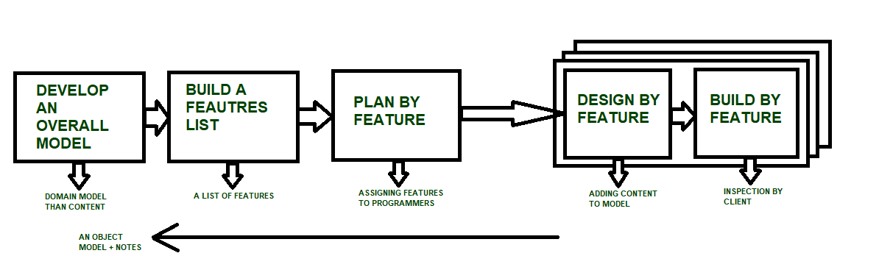

Characteristics of FDD
- Short iterative: FDD lifecycle works in simple and short iterations to efficiently finish the work on time and gives good pace for large projects.
- Customer focused: This agile practice is totally based on inspection of each feature by client and then pushed to main build code.
- Structured and feature focused: Initial activities in lifecycle builds the domain model and features list in the beginning of timeline and more than 70% of efforts are given to last 2 activities.
- Frequent releases: Feature-driven development provides continuous releases of features in the software and retaining continuous success of the project.

Advantages of FDD
- Reporting at all levels leads to easier progress tracking.
- FDD provides continuous success for larger size of teams and projects.
- Reduction in risks is observed as whole model and design is build in smaller segments.
- FDD provides greater accuracy in cost estimation of the project due to feature segmentation.

Disadvantages of FDD
- This agile practice is not good for smaller projects.
- There is high dependency on lead programmers, designers and mentors.
- There is lack of documentation which can create an issue afterwards.

